# Unit 3

# ( With Try outs Ex : 6)

# Linear Algebra

Solving a Linear System

A linear algebraic equation is an equation of the system

a1 x1+a2 x2+a3 x3+⋯+an xn=b

where a's are **constant coefficients**, the x's are the **unknowns,** and b is a **constant.** A solution is a sequence of numbers s1,s2, and s3that satisfies the equation.

**Example**

4x1+5x2-2x3=16

is such an equation in which there are three unknown: x1,x2,andx3. One solution to this equation is x1=3,x2=4 and x3=8,since 4\*3+5\*4-2\*8 is equal to 16.

A **system** of a linear algebraic equation is a set of the equation of the form:

a11 x1+a12 x2+a13 x3+⋯+a1n xn=b1  
a21 x1+a22 x2+a23 x3+⋯+a2n xn=b2  
a31 x1+a32 x2+a33 x3+⋯+a3n xn=b3  
am1 x1+am2 x2+am3 x3+⋯+amn xn=bm

This is called an **m\*n** system of equations; there are m equations and n unknowns.

Matrix FormsBecause of the method that matrix multiplication works, these equations can be defined in the matrix form as Ax = b where A is the matrix of the coefficients, x is the column vector of the unknown, and b is a column vector of the constant from the right-hand side of the equations:

A           x      =       b

a11 a12 a13...a1n       x1       b1  
a21 a22 a23...a2n       x2       b2  
a31 a32 a33...a3n       x3       b3  
.............................       .............       ........  
am1 am2 am3...amn       xn       bm

A **solution set** is a set of all possible solutions to the system of equation (all sets of value for the unknowns that solve the equation). All systems of linear equations have either:

* No solutions
* One solution
* Infinitely many solutions

**Solution using matrix Inverse**

Probably the simple way of solving this system of equations is to use the matrix inverse.

A-1 A=1

We can multiply both sides of the matrix equation AX= B by A-1to get

A-1 AX=A-1 B

Or

X=A-1 B

So, the solution can be found as a product of the inverse of A and the column vector b.

**In MATLAB, there are two methods of doing this, using the built-in**

**(i) inv function and matrix multiplication, and also using the (ii) "\" operator:**

3x1+4x2+x3=2 ;

-2x1 +3x3 = 1;

x1+2x2+4x3 =0

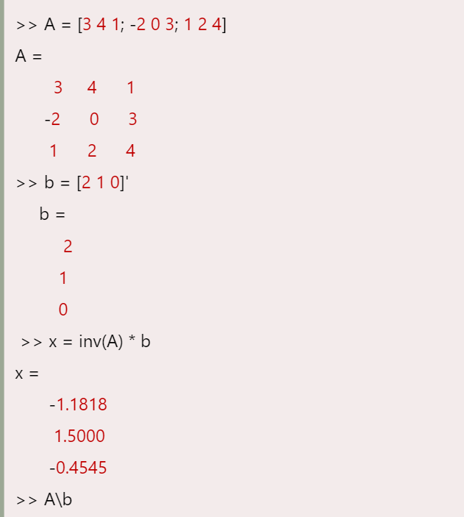

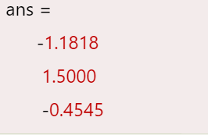

[x](https://in.mathworks.com/help/matlab/ref/mldivide.html#btg5qam-x) = mldivide([A](https://in.mathworks.com/help/matlab/ref/mldivide.html" \l "mw_b8923d43-9b0d-494b-9dd6-97428b8963bf),[B](https://in.mathworks.com/help/matlab/ref/mldivide.html#mw_b8923d43-9b0d-494b-9dd6-97428b8963bf)) is an alternative way to execute x = A\B, but is rarely used.

**System of Equations**

Solve a simple system of linear equations, A\*x = B.

A = magic(3);

B = [15; 15; 15];

x = A\B

x = *3×1*

1.0000

1.0000

1.0000

**Linear System with Singular Matrix**

Solve a linear system of equations A\*x = b involving a singular matrix, A.

A = magic(4);

b = [34; 34; 34; 34];

x = A\b

x = *4×1*

0.9804

0.9412

1.0588

1.0196

Solving 2x2 Systems of Equations

The simplest system is a 2 x 2 system, with just two equations and two unknowns. For these systems, there is a simple definition for the inverse of a matrix, which uses the determinant D of the matrix.

For a coefficient matrix, A generally defined as :

a11x1 +a12x2 = b1

a21x1 + a22x2 = b2

Linear Algebra

the determinant D is defined as a11 a22-a12 a21

Linear Algebra

**Example**

**x1+3x2=-2  
          2x1+4x2=1**

This would be written in matrix form as

Linear Algebra

The determinant D = 1\*4 -3\*2 = -2.

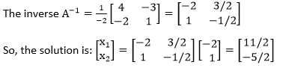

X=A-1 B

MATLAB has built-in functions **det** to find the determinant of the matrix.

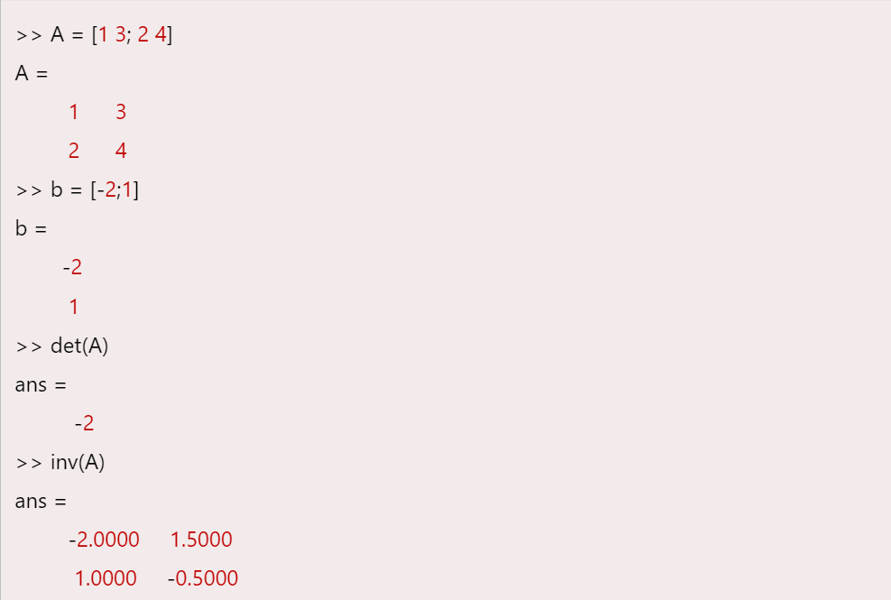

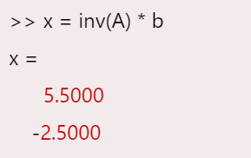

Gauss Elimination to solve Linear Equations :

It is based on the observation that systems of equations are equivalent if they have the same solution set and performing simple operations on the rows of a matrix, known as the **Elementary Row Operations** or **(EROs)**.

**There are 3 EROs:**

1. **Scaling:** Multiplying a row by a scalar (meaning, multiplying every element in the row by the same scalar). This is written sri⟶ri, which indicates that row i is modified by multiplying it by a scalar s.
2. **Interchange:** Interchanging the locations of two rows. This is written as ri⟵⟶rjwhich indicates that rows i and j are interchanged.
3. **Replacement:** Replacing all of the elements in one row with that row plus or minus a scalar multiplied by another row. This is written as ri± srj⟶ri.

Example

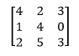

An example of interchanging rows would be r1⟵⟶r3.

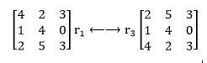

Now, starting with this matrix, an example of scaling would be: 2r2⟶r2,which describes all items in row 2 are multiplied by 2.

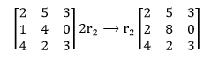

Now, starting with this matrix, an example of a replacement would be: r3-2r2⟶r3.

Element-by-element, row 3, is replaced by the element in row 3 minus 2 \* the corresponding items in row 2. These yields:

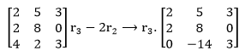

Both the Gauss and Gauss-Jordan methods begin with the matrix form Ax = b of a system of equations, and then augment the coefficient matrix A with the column vector b.

Gauss Elimination

The Gauss Elimination method is a method for solving the matrix equation Ax=b for x.

The process is:

1. It starts by augmenting the matrix A with the column vector b.
2. It executes EROs to convert this augmented matrix into an upper triangular form.
3. It uses back-substitution to solve for the unknowns in x.

Example

Use a 2 x 2 system, the augmented matrix would be:

Gauss and Gauss-Jordan Elimination

Then, EROs are used to get the augmented matrix into an upper triangular form:

Gauss and Gauss-Jordan Elimination

So, it is simply to replace a21 with 0. Here, the primes indicate that the values have been change.

Putting this back into the equation form yield

Gauss and Gauss-Jordan Elimination

Executing this matrix multiplication for each row results in:

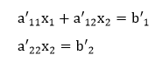

So, the solution is:

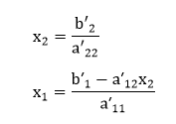

Similarly, for the 3x3 system, the augmented matrix is reduced to an upper triangular form:

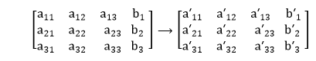

This will be done orderly by first getting a0in the a21 position, then a31, and finally a32.

Then, the solution will be:

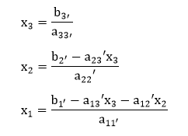

Consider the following 2x2 system of equations:

x1+2x2=2  
2x1+2x2=6

As the matrix equation Ax = b, this is:

Gauss and Gauss-Jordan Elimination

The first process is to augment the coefficient matrix A with b to get an augmented matrix [A| b]:

Gauss and Gauss-Jordan Elimination

For the forward elimination, we need to get a0 in the a21 position. To accomplish this, we can change the second line in the matrix by subtracting from it 2 \* the first row.

The way we would write this ERO is:

Gauss and Gauss-Jordan Elimination

Now, putting it back in the matrix equation form:

Gauss and Gauss-Jordan Elimination

says that the second equation is now -2x2= 2 so x2 = -1. Plugging into the first equation:

x1+2(-1)=2  
x1=4.

This is called a **back-substitution**.

Guass elimination method

x1+3x2 =1

2x1+x2+3x3 =6

4x1+2x2+3x3 = 3

>> a = [1 3 0; 2 1 3; 4 2 3]

a =

1 3 0

2 1 3

4 2 3

>> b = [1 6 3]'

b =

1

6

3

>> ab = [a b]

ab =

1 3 0 1

2 1 3 6

4 2 3 3

>> ab(2, :) = ab(2,:) - 2\*ab(1,:) // r2 = r2 – 2\*r1

ab =

1 3 0 1

0 -5 3 4

4 2 3 3

>> ab(3,:) = ab(3,:) - 4 \* ab(1,:) // r3 = r3-4\*r1

ab =

1 3 0 1

0 -5 3 4

0 -10 3 -1

>> ab(3,:) = ab(3,:) - 2 \* ab(2,:) // r3= r3-2\*r2

ab =

1 3 0 1

0 -5 3 4

0 0 -3 -9

>> ab(2,:) = ab(2,:) + ab(3,:) // r2 =r2+r3

ab =

1 3 0 1

0 -5 0 -5

0 0 -3 -9

>> ab(1,:) = ab(1,:) + 3/5\*ab(2,:) // r1 = r1+3/5\*r2

ab =

1 0 0 -2

0 -5 0 -5

0 0 -3 -9

Hence, x1= -2/1 = -1 ,

x2 = -5/-5 = 1

,x3 = -9/-3 = 3

TRY OUTS :

Ex : 6 SOLVE : USING

Given system of equations are:

x + y + z = 2

x + 2y + 3z = 5

2x + 3y + 4z = 11

1. INV
2. \
3. GAUSS ELIMIATION